Asimov, Robot Dreams, Berkley Books November 1986, No dust jacket. Fine trade paperback with all 349 pages tightly bound and no marks. Illustrations by Ralph McQuarrie. ISBN 042509345X
This collection spans the body of Isaac Asimov’s fiction from the nineteen-forties to the mid-eighties. The stories are all the classic themes. The opening story is a never-before-published by Asimov. It represents the first appearance of Asimov’s heroine, Dr. Susan Calvin, in over a decade.

ID 000302 Price $12 Box 12
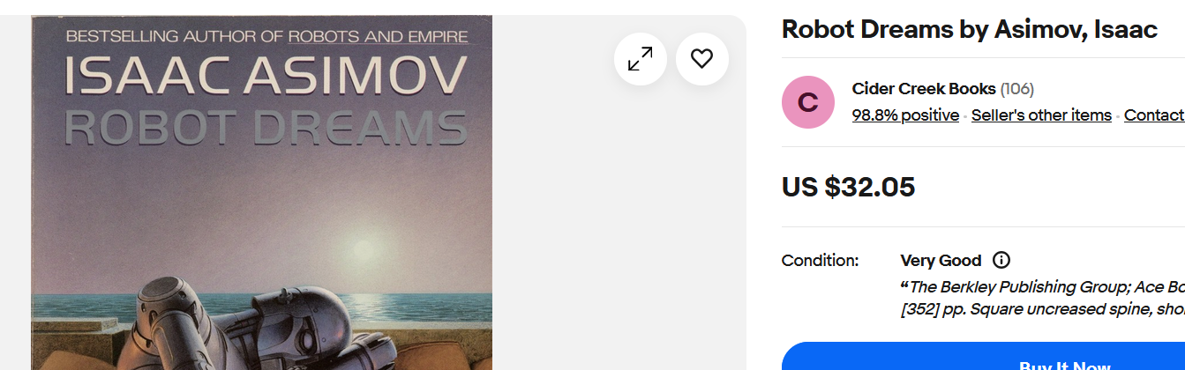
Ebay

